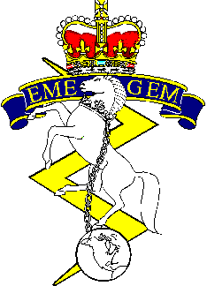
2022 WESTERN RCEME GOLF
TOURNAMENT REGISTRATION FORM

Edmonton Garrison Memorial Golf and Curling Club

12 0900 August 2022: Shotgun Start 4 Ball-Best Ball (Single Round)

Menu Items available for purchase at EGMGCC throughout.

Payment and Registration

**Cash or E-Transfer** Accepted
**E-Transfer to westernrcemefund@gmail.com **

Entry Fee: $210.00 per team (2x Cart)
$180.00 per team (NO Cart)
-$40.00 discount per members of Edmonton Garrison Memorial Golf and Curling Club
(must provide ID)

Must Register by 27 Jul 22
Team Name:____________________________________
Golfer | Name | Member of EGMGCC? (Yes/No)
1
2
3
4
Spare
No fee for spares. Only 4 golfers permitted on green at a time.

Check any that apply:

Total Due: $__________________ □ Cash Enclosed □ E- Transfer
At Least one RCEME member or past member on team.
Please submit registration form and proof of payment to:
Lt Munson, Maint Coy 1 Svc Bn, by 27 Jul 22.
Colin.Munson@forces.gc.ca
Tel: 780-973-4011 Ext: 6369

