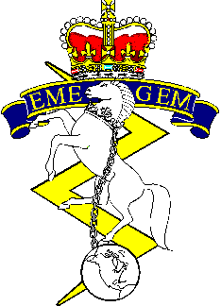
2019 WESTERN RCEME GOLF
TOURNAMENT REGISTRATION FORM

Edmonton Garrison Memorial Golf and Curling Club

29 0800 August 2019: Shotgun Start 4 Ball-Best Ball (Single Round)

Entry includes Golf Carts, BBQ Style Hotdog & a Beer.

Menu Items available for purchase at EGMGCC throughout.

Payment and Registration

Cash, Cheques* or E-Transfer** Accepted

*Cheques payable to “Western EME Fund” – No post-dated cheques, please.*
**E-Transfer to westernrcemefund@gmail.com **

Entry Fee: $60.00 per person (non-members)
$25.00 for members of Edmonton Garrison Memorial Golf and Curling Club
(must provide ID)

Must Register by 22 Aug 19
Team Name:____________________________________
Golfer | Name | Member of EGMGCC? (Yes/No)
1
2
3
4
Spare
No fee for spares. Only 4 golfers permitted on green at a time.

Check any that apply:

Total Due: $__________________ □ Cheque Enclosed □ E- Transfer □ Cash Payment
At Least one RCEME member or past member on team.
Please submit registration form and payment to:
Sgt Terence Svensrud, Maint Coy 1 Svc Bn, by 22 August 2019.
TERENCE.SVENSRUD@FORCES.GC.CA
TEL: 780-973-4011 X 2176

