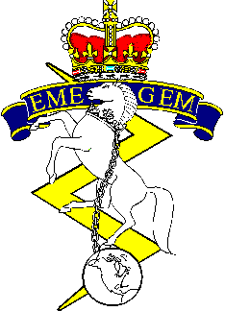
2019 WESTERN RCEME GOLF
TOURNAMENT REGISTRATION FORM

Edmonton Garrison Memorial Golf and Curling Club

11 1700 July: Meet and Greet @ EGMGCC
12 0800 July: Shotgun Start Best Team
13 0800 July: Shotgun Start 4 Ball-Best Ball

Free banquet snacks at Meet and Greet. Menu items avail for purchase.

BBQ for lunch on 12 & 13 (Hole 6): $3.00 for a hamburger
$2.00 for a hotdog

Pay at Registration:
*Cheques payable to “Western EME Fund” – No post-dated cheques, please.*

Entry Fee: $120.00 per person (non-members)
$50.00 for members of Edmonton Garrison Memorial Golf and Curling Club
(must provide ID)

Must Register by 04 July 19
Team Name:____________________________________
Golfer | Name | Member of EGMGCC? (Yes/No)
1
2
3
4
Spare
No fee for spares. Only 4 golfers permitted on green at a time.

Check any that apply:

Total Due: $__________________ □ Cheque Enclosed
At Least one RCEME member or past member on team.
Please submit registration form and payment to:
Sgt Terrance Svensrud, Maint Coy 1 Svc Bn, by 04 July 19.
TERENCE.SVENSRUD@FORCES.GC.CA
TEL: 780-973-4011 X 2176

