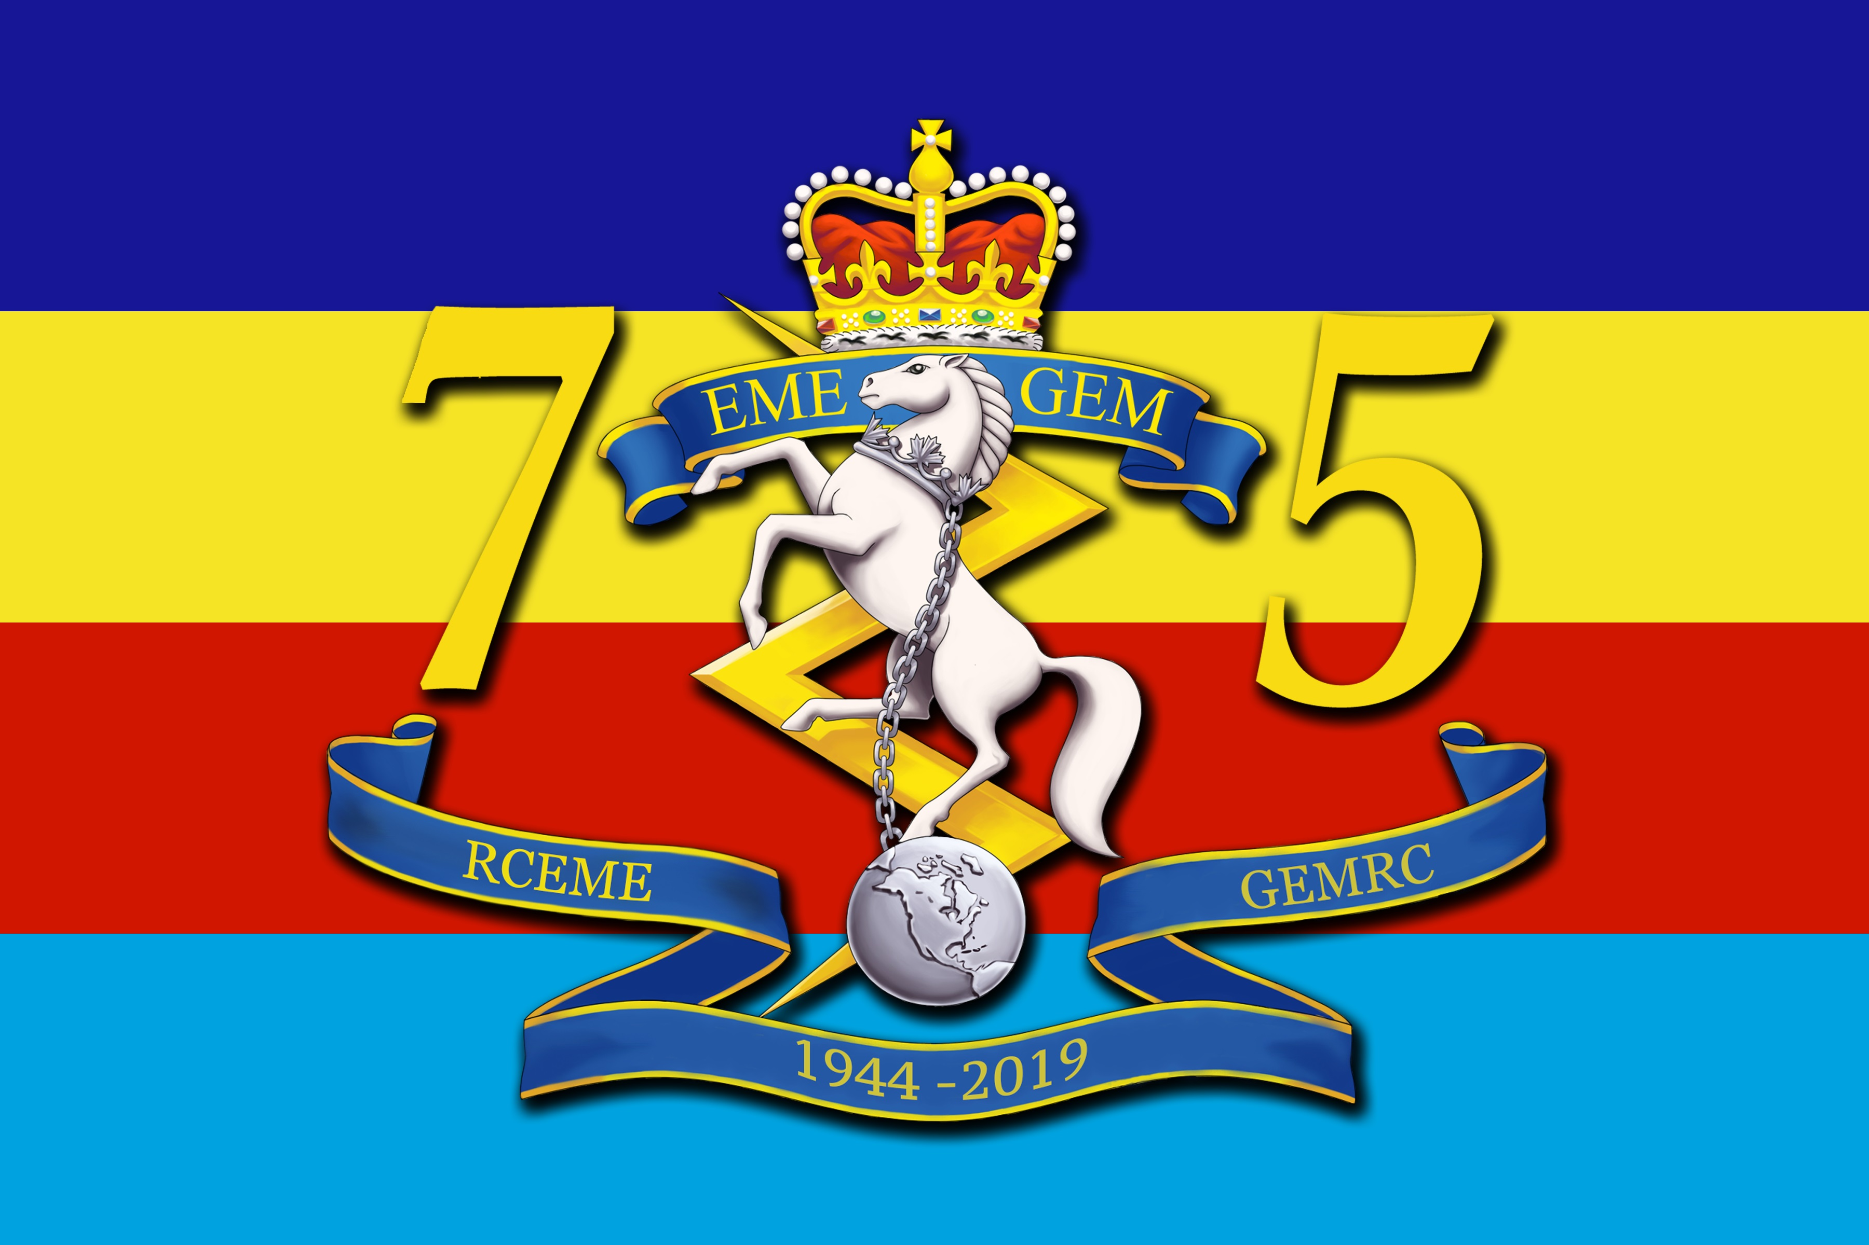
Date: 15 Oct 2018

Western RCEME Bonspiel Chairman
1 Service Battalion
Edmonton Garrison

ENTRY FORM – 49th ANNUAL

WESTERN RCEME CURLING BONSPIEL

- The following team from wishes to compete in the subject Bonspiel held at Edmonton Garrison from 21 – 24 February 2019. Each team MUST be made up of at least one current or former RCEME member who will be on the ice at each game. Entry Fees are $300.00 per 4-man rink and $50.00 per spare.
- There will also be________additional guests attending the Banquet at $30.00 each.

POSITION | RANK | TEAM NAME:  NAME /INIT | FIRST/NICKNAME | LOCAL
SKIP
VICE
LEAD
SECOND
SPARE

 | # PERS | TOTAL COST
TEAM ENTRY FEE

SPARE

ADDITIONAL
BANQUET TICKETS
 | TOTAL

The cut-off date for registrations is 20 Feb 2019 and due to financial commitments, no refunds will be made after 15 Feb 19. The Bonspiel can accommodate up to 64 Teams.

- My team requires a late draw time. (curling starts at 1700 21 Feb 19) YES NO

- Will any mbr of your team require RV parking? YES, number NO

- Payments can be made in cash, by cheque (payable to Western RCEME Fund) or via e-transfer to: globetrotter178@gmail.com

- If accommodations are required please call Base Accommodations at 780-973-4011 ext 4523 or
email: +edm r@q or Edm-ASU-R&Q@forces.gc.ca

- Any further questions may be addressed thru your Unit OPI or to MCpl Dufresne at 780 973 4011 ext 2167 or email: Francis.Dufresne@forces.gc.ca

