RCEME History: Heavy Tank Recovery in the Western Army. The Mighty Mouse.

As the RCEME 75th Anniversary Approaches, and the task for the 3rd Canadian Division RCEME Soldiers is to run a Repair and Recovery Challenge, it’s appropriate that we look back on our past successes in heavy tank recovery. Being the Canadian Army’s heavy division is not a new development, the Canadian Army has for a long time used the prairies as Tank training ground, and this was true in training for WW2 and the post WW2 years.

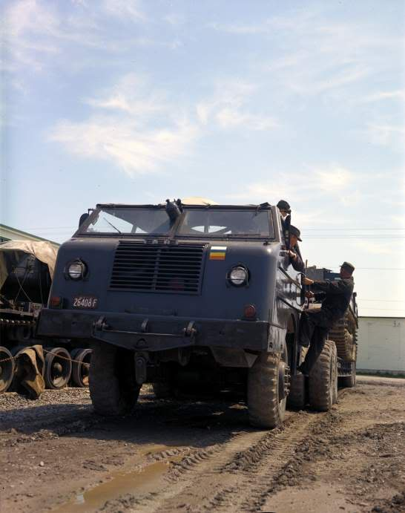
During WW2 the US Army determined that it had a gap in its ability to recover and haul the increasingly heavy Tanks being brought into service. And they contracted Pacific Car and Foundry Co. of Seattle, WA, to produce a heavy truck more capable than the M20 Diamond T that was in service until then. In the end the US Army procured 48 M26/M26A1’s and Canada procured 3 M26A1’s to recover and haul our 54 Ton Centurion Tanks.

The US called these Dragon Wagon’s, but in Canada they were referred to as the “Might Mouse” due to their ability to recover and haul tanks much larger and heavier than the truck was.

Not only were they able to attach a heavy haul trailer, similar to what we now use with the “Tru-Hitch” recovery trailer, but they had two 30 Ton winches, capable of a combined 60 Ton one to one extraction.

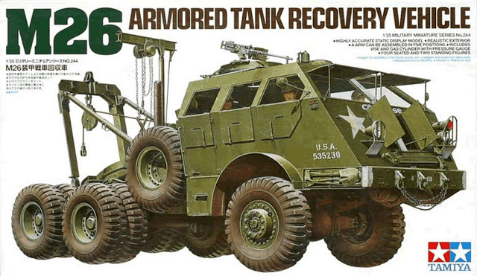
Two of these Might Mouse M26A1 trucks were employed in Western Command in Calgary in the 50’s, with the third one used at the RCEME School for training.

These were primarily used by the 53rd Light Aid Detachment, which was attached to Lord Strathcona’s Horse Regiment.

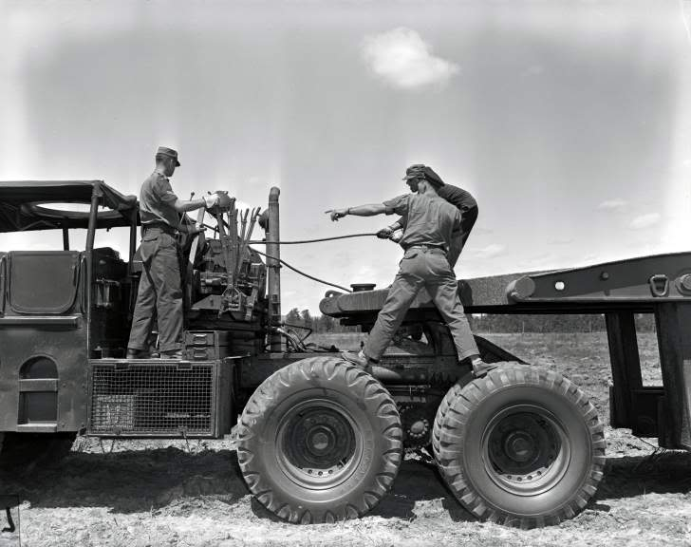

This Mighty Mouse, used by the RCEME Soldiers in Western Canada to recover and haul Main Battle Tanks in the 50’s is a legacy that is not lost on us as we face the current challenges of Leopard MBT sustainment, and move forward to the 75th Celebrations and practising our craft in a Repair and Recovery Challenge in Wainwright, AB, in early Sept 2019.

